My Story
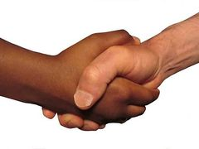
What is your name?
My name is ________________________.

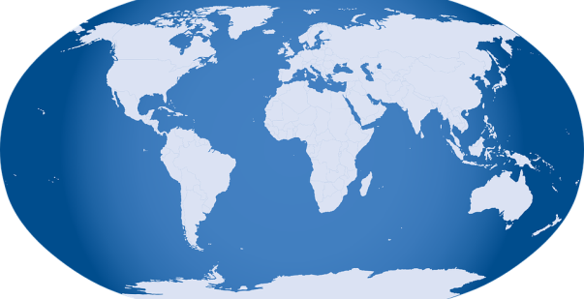
Where are you from?
I come from ________________________.

What languages do you speak?
I speak ____________________________.

What year did you come to Canada?
I came to Canada in __________________.

Who are your classmates?
My classmates are: ___________________ _________________
________________ ___________________ _________________
________________ ___________________ _________________

